Issue #1 (Done)

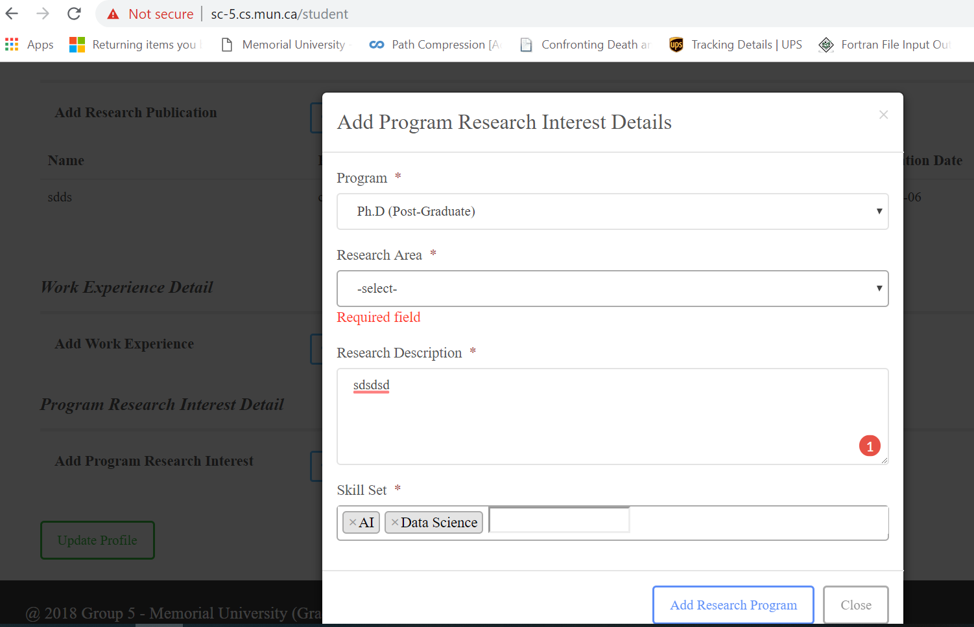

I tried to **Add Program Research Interest, I need to select research area. But there is nothing to select! So it won’t let me to finish this.**

**-----**

**Suggestion #1:**

**it would be nice if when the student sign in for the first time we tell him to start making his profile to start the process. For example we can put a link “ APPLY HERE” in the home page that takes the user to student profile.**

**Currently if the student click on “ Become a student” it is just some text. It would be nice if there is a link that takes students to profile page.**

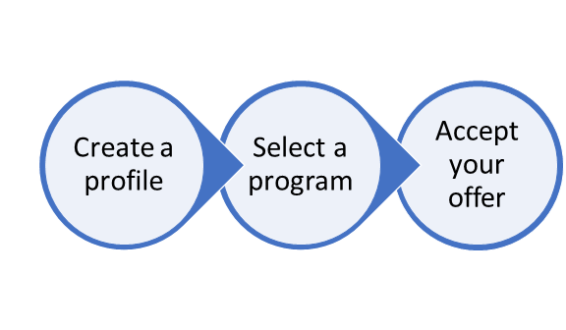

**Having something like this that shows the workflow is also very nice. Because when the prof wants to test our site it is easier for him.**

**----------------**

**Issue #2 (Fixed)**

**Cannot Add more than one program research interest. It will delete the first one or at least doesn’t show it.**

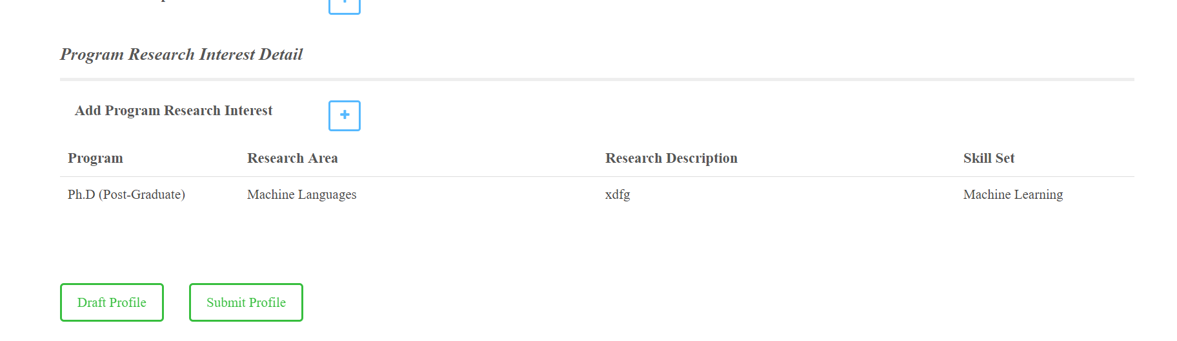

**=============**

**Issue #3**

**In the profile section the student can input integer for experience months**

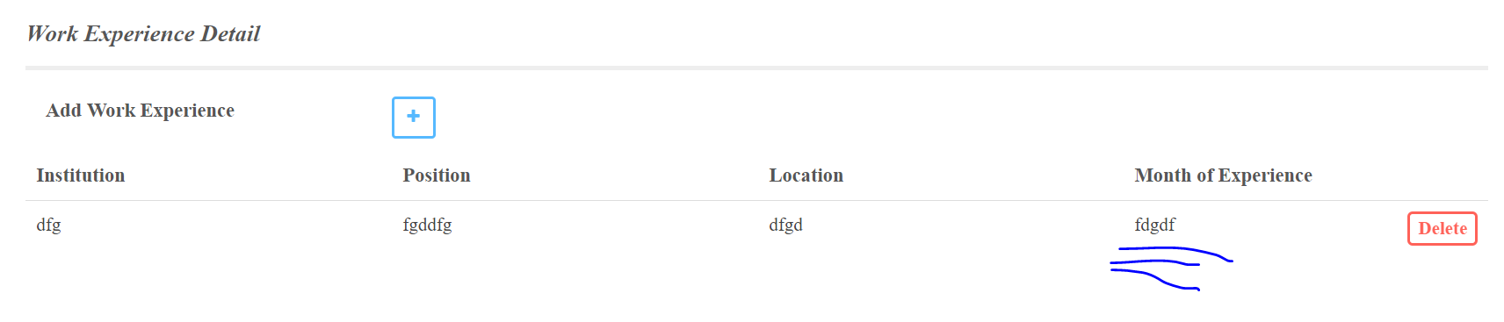

**============**

**Suggestion #2 (Done)**

**When students add a publication it is better to same “title” rather than” name”**

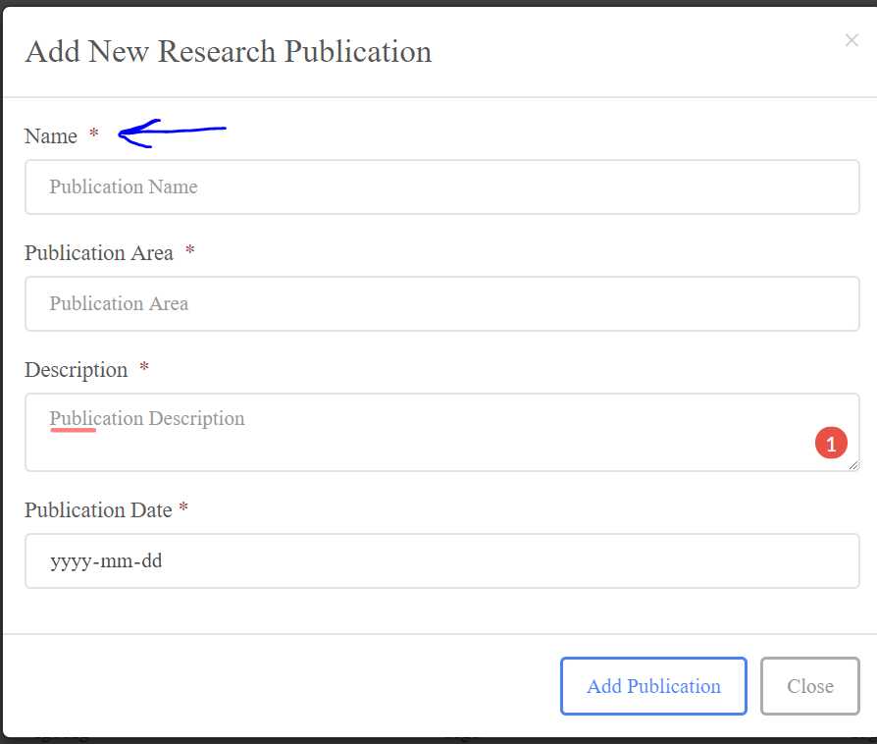

**===============**

**----------------------**

**Suggestion#3 (Disable control)**

**Stop stupid students from regestering their made-up courses:** 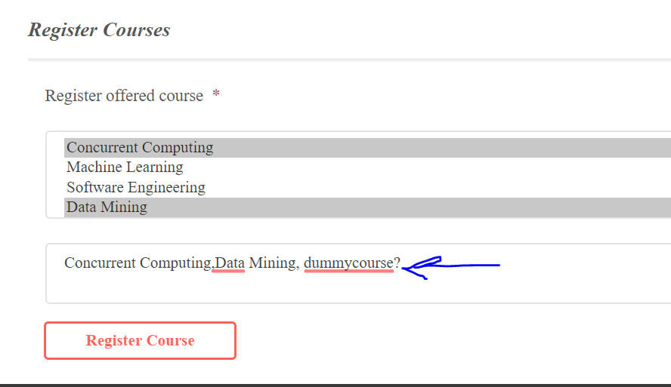

**-----------**

**Issue #4: when the student register for another course, all the previous courses are deleted. Maybe it is ok. But do you think it’s a good idea if we disable the register button once the students registers once?**

**----------------------------**